Book Challenge: 13 Books in a School Year
Name: ___________________________________

Challenge | Book Title/Author | Date Started-Completed
A book published in 2017 or 2018
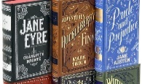
A “classic” book
(older than your great grandparents)
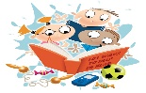
A picture book
Biography or Autobiography
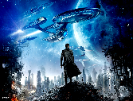
Fantasy/science fiction
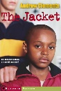
Realistic Fiction
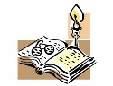
Historical Fiction
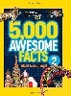
Nonfiction (not a
biography/autobiography)
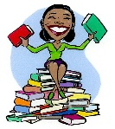
A book recommended by Mrs. Williams
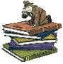A mystery
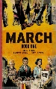
A graphic
novel
Your choice
A book made into a movie

